Decetralized Voting System

Bhavin Patil
Dept. of Computer Engineering
Vishwakarma Institude of Technology
Pune, India
bhavin.patil21@vit.edu
Chaitanya Patil
Dept. of Computer Engineering
Vishwakarma Institude of Technology
Pune, India
chaitanya.patil21@vit.edu
Manasi Patil
Dept. of Computer Engineering
Vishwakarma Institude of Technology
Pune, India
manasi.patil21@vit.edu
Uma Thakur
Dept. of Computer Engineering
Vishwakarma Institude of Technology
Pune, India
uma.thakur21@vit.edu

Abstract—The voting technique is the process for putting the people's opinion into action in order to better govern the system. However, the voting system in India, as well as in many other countries, has indeed been defective in recent years and may be easily manipulated and hampered by figures of authority for their own personal gain. They aren't fully secure because ballots are easy to tamper with. It also raises concerns about voter security and transparency. Furthermore, counting the votes takes an excessive amount of time. To address these issues, citizens in many nations use digital technology during the voting process. Digitalization would not be enough to solve every one of the problems. Digital technology can also be manipulated or altered in a number of ways. The foundation of our product is built on blockchain technology. This research work combines digitalization with blockchain technology to develop a voting mechanism by analyzing the aforementioned challenges. Our voting mechanism's key goals are to ensure voter integrity, anonymity, privacy, and security. The system can be used to highlight a number of popular blockchain frameworks that provide blockchain as a service as well as an electronic E-voting system. Based on the results of this study, we propose a decentralized e-voting protocol based on blockchain technology, that removes a need for a trusted third party.

Keywords—Blockchain Technology, Distributed System, End to End Transactions, Smart Contract, Mining, Electronic Voting System and E-voting.

Introduction
This document describes the structural properties and software requirements of Decentralized Voting System

Vision
The vision of this document is to make the Decentralized Voting System's functional and non-functional requirements understandable. It also assists to make the functionality of the system evident to end users.

Scope of the Project
The Decentralized Voting System is intended for people from all around the world who want to vote for their country's representative. The election can indeed be done in one of two ways: by paper ballot or through automated ballot.
Electronic voting is a term for automated ballot elections. The Decentralized Voting System has progressed to the point where it can replace the online polling system using accurate and direct voting online and immediate results.
Because the Decentralized Voting System is carried out over the internet, it is also known as Internet Voting.

Goals and Objectives
Goal:
Our project's major goal is to create a set of protocols that allows voter to vote at any field areas by using if they prefer online voting. We are using blockchain technology which allow digital information to be recorded and distributed, but not edited and we are using this concept in our project.

Objectives:
Following are the objectives of our project:

- To assess the ability of election systems to appropriately conduct safe, useful, and accessible elections in order to provide voters confidence that the election is a true expression of their will.

- To facilitate the interoperability of election systems

- To enable voters and election jurisdictions to examine the performance and capability of election systems in an open and transparent manner.

Literature Survey
Using various tactics and procedures, a range of approaches have been created to introduce variations in electronic and online voting systems. While some of them provide some level of secrecy and security to the system, contemporary technologies that ensure and guarantee the security and privacy of voters and voter information must manage and regulate the voting information and process.

Basic approach/architecture of E-voting:
Basic E-voting strategy/architecture: To ensure secure data transactions, systems that are developed to cast votes using a digital approach using online portals and electronic devices use a multitude of encryption and decryption techniques.

Homomorphic Encryption Technique:
Homomorphic encryption is a versatile technology with numerous uses. It was most recently employed in the development of an online voting system. In the voting system based on this encryption, the exponential ElGamal cryptosystem is used. Before being sent, the contents of each cast ballot are encrypted using the exponential ElGamal encryption. The additive homomorphism feature of this crypto system allows for rapid tallying of encrypted ballots with no need to decrypt them.

Centralized architecture:
However, there are a variety of approaches for converting data into a coded format to prevent manipulation when transmitting over the network. One disadvantage that might be highlighted here is that when the correct data has been stored in the database, a high level of trust and security is necessary. If the data is valuable, centralized storage is unpleasant since illegal access and hacker attacks will put the system's reliability in jeopardy.
The centralized architecture approach is used to apply previous concepts and designs. This could lead to ethical and security issues. We put the data at danger by collecting it in a centralized location. It is possible to control it in an inequitable manner. As a result, the fair framework uses blockchain to solve the challenge of storing information in a distributed fashion. Blockchain is a decentralized ledger that keeps track of all completed transactions in chronological order.
Traditional databases are managed by a single organization, which has complete control over the database, including the capacity to modify the recorded data, censor otherwise acceptable data changes, and fraudulently add data. This isn't a problem in most circumstances because the entity that maintains the database does so for a reason.
It has no incentive to misrepresent the database's contents for its own gain; but, in other circumstances, such as a financial network, the data being stored is too sensitive and the incentive to modify it is too appealing to allow any single institution to have complete control over the database. Even if it were possible to ensure that the responsible organization would never make a false update to the database (an assumption that is already too much to expect for many people), a hacker might still break in and manipulate the database to their own ends.

Blockchain (Decentralized) Architecture:
Blockchain technology solves these issues by establishing a network of computers (referred to as nodes) that individually hold a copy of the database, as well as a set of rules (referred to as the consensus protocol) that govern the order in which nodes can add new updates to the database. As a result, all nodes agree on the state of the database at any one time, and no single node has the ability to falsify data or censor modifications. The blockchain also mandates the preservation of an audit trail of all database modifications, allowing anybody to verify that the database is correct at any moment. Individual modifications to the database, referred to as transactions, make up this audit trail. A block is a collection of transactions that were all added by a single node at the same time. Each block has a reference to the block before it, which sets the blocks' order. This is where the word "blockchain" comes from: it refers to a sequence of blocks, each of which contains a link to the previous block as well as a list of new transactions since that block. When a new node joins the network, it starts with an empty database and downloads all the blocks, applying the transactions to the database to bring the database up to speed with the rest of the network. In essence, a blockchain specifies the sequence in which transactions were applied to the database so that anyone can verify the database's accuracy by reconstructing it from the ground up and ensuring that no changes were made improperly.

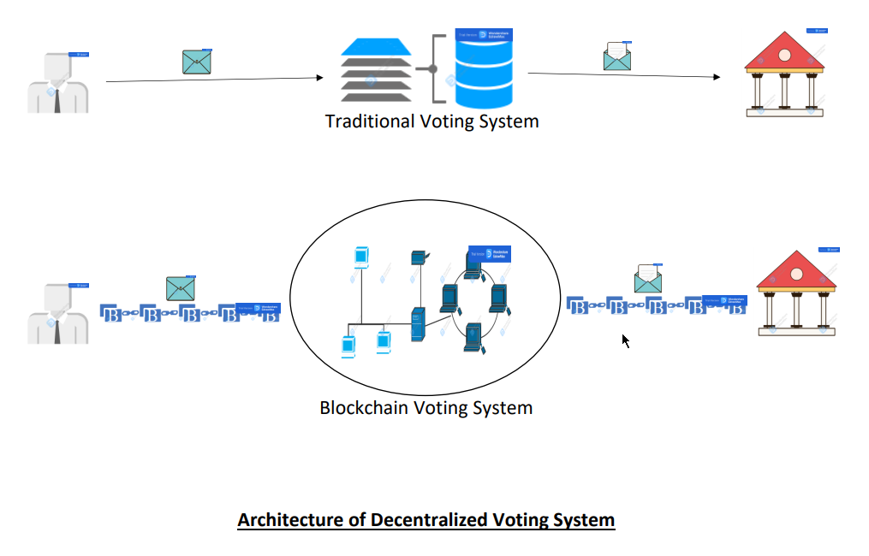

Specific Requirements

Interface Requirements

User Interfaces: The system must have a user interface that is accessible via all Web browsers for all sorts of users. For Election Mode and Normal Interactive Mode, the voter interface must be distinct.

Hardware Interfaces: This software system does not have any physical interfaces. The only way to communicate is through a computer system.
3) Software Interfaces: The poll server is powered by a http server that can handle server pages. It keeps track of the polls in a relational database, which it connects to using normal database connectivity APIs. The environment must have a Java Virtual Machine running in order to run the setup software.

Functional Requirements

Data Management of the System: Massive volumes of data are created during the election process. As a result, data must be collected in a system manner.

Blockchain Storage: A hash value resulting from voter information is deposited on the genesis block as a list of voters in the voting blockchain, and each vote is preserved as a block in the chain. The metadata of the Election Commission's database is stored on a different type of blockchain.

3)Registration of Voters: The following are the steps in the voter registration process:

- Each person must go to their local voter registration office and complete out the proper documentation in order to be a legitimate voter.
- A key generation algorithm will be utilized to generate a public and private key pair
- In the blockchain network, the public key is used to identify voters. The private key is transmitted to the voters' mobile phone numbers. They can vote and participate in the voting process using this private key.
- A hash is generated from a voter's provided fingerprint using a fingerprint hash generation technique. The entire process of hash generation from voter-submitted data.
- The generated hash will be merged with the additional information provided by the voters to generate a new hash value.
- The final hash value will be placed as a voter list in the blockchain's genesis block.

Where the hash value equals the proof-of-membership value.
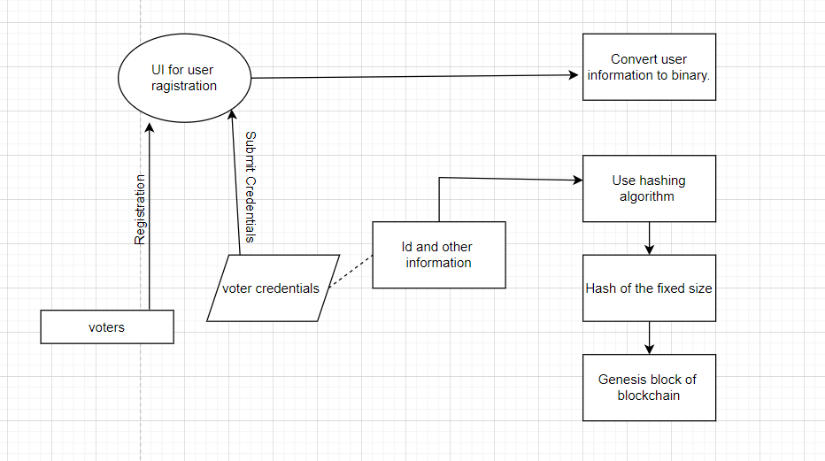

4)Registration of Voters:
As the candidate also falls in the category of the voter, both registrations are compatible for each other’s. The unique values for the candidates are also stored in the genesis block at the time of registration.

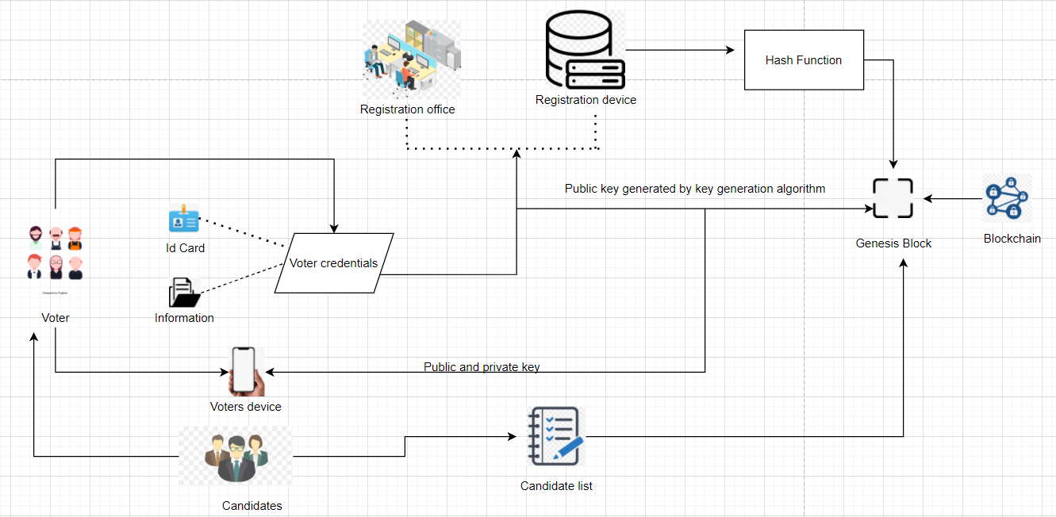

5) Vote Casting using smart contract: Here is the list of the functions that runs on the blockchain for smart contract:

- Need to verify the genuine identity of the voter:
  - The voter used the internet enabled device to log into the system using the private code/key.
  - Need to provide, NID, fingerprint and other personal information.
  - While processing the information on blockchain smart contract checks with the information present on the genesis block.
  - If everything goes correct the candidate list is presented to the voter.

- Create a Block for Casted Vote:
- The voter has to select the candidate form the list.
- Digital signature is used to cast the vote and then the transition is reported to the SC.
- SC have to produce VID for voter’s vote.
- Then incrimination of the votes for the candidate is takes place.
- Create the block that includes the vote information.

- Miner Selection:
  - Specific algorithm is used by SC to identify the minor and to trash it.

- Generate Hash:
  - SC nominated miner that is modified the block as it has been updated with the current mined hash inside the block.
  - The process of generation of the hash that is meant to be a large number of noticeable zero is started by the miner i.e. also known as the proof of the work.
  - Then the required hash of the block is added to the network and at the end miner get the monitory as reward.
  - Like for any digital currency, i.e., Bitcoin that requires the ample number of resources as the miners have the race to win by producing the block’s mission hash to avoid the record interfaces.

- Verify Block:
  - After the addition of the vote into the chain is done, SC has to vanish the value of hash from the list of voters and then add that value to another list named Already voted to reach the optimum accuracy.
  - Return the voter's VID so that their vote may be verified in the blockchain.

- Counting of Votes:
  - The number of votes in each block will be counted by the smart contract. The vote is counted immediately as it is submitted, therefore there is no danger of voting manipulation or fraud.

Non-Functional Requirements
- Public Verifiability: All users who are in the election process need to verify independently the election's whole method and outcome.

- Individual Verifiability: Every voter needs to check if his or her vote was correctly recorded and counted.

- Dependability or Reliability: To protect against assaults, asymmetric-key encryption and various blockchain methods are used. To ensure that only genuine and confirmed votes are added to the blockchain network, digital signatures are used to validate or confirm the casted votes.

- Consistency: All blocks have the similar copy of records at any given time, and all of them will have the same end result after the election process is completed, thanks to blockchain's consensus mechanisms.

- Auditability: If necessary, the entire operation can be audited after the election.

- Anonymity: There is no link between voters and their votes. Cryptography and the implementation of zero-knowledge proofing which validate casted votes anonymity.

- Openness: As it is both secure and transparent, the complete procedure is open to the public.

- Scalability: The digital signature process is based on a short-linkable ring signature, which will handle a all the voters.

- Eligibility: Ensuring the users who are eligible to have access the system.

- Authentication: Ensuring a unique voter ID and other credentials, users can use the e-voting system.

- Objectivity: The casted votes can only be counted when the full election process has been completed, which can be only done by decrypting the encrypted blocks from blockchain network.

Software Requirements
- Operating System: Windows 10.
- Framework: Visual Studio, Remix, Solidity, Truffle, Ganache, NodeJS
- Database: MS-SQL Servers or SQLite

Hardware Requirements
- Storage: Minimum 50GB of Hard Disk Drive or Solid-State Drive.
- Processor: Intel Quad core 1.50 GHZ Processor or any higher processors.
- Memory: Minimum 8GB of RAM.

Diagrams

Use Case Diagram:
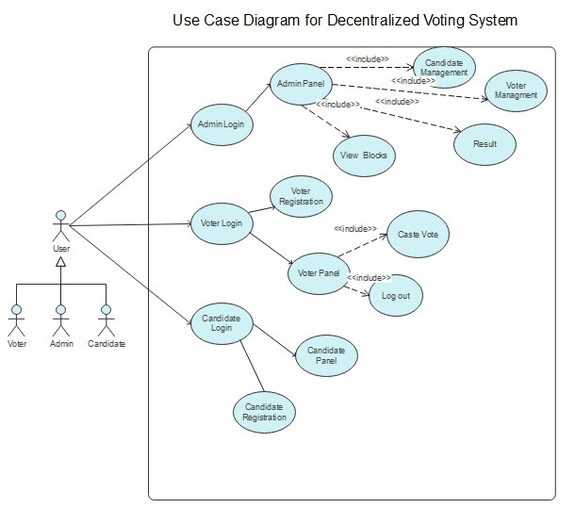

Class Diagram:
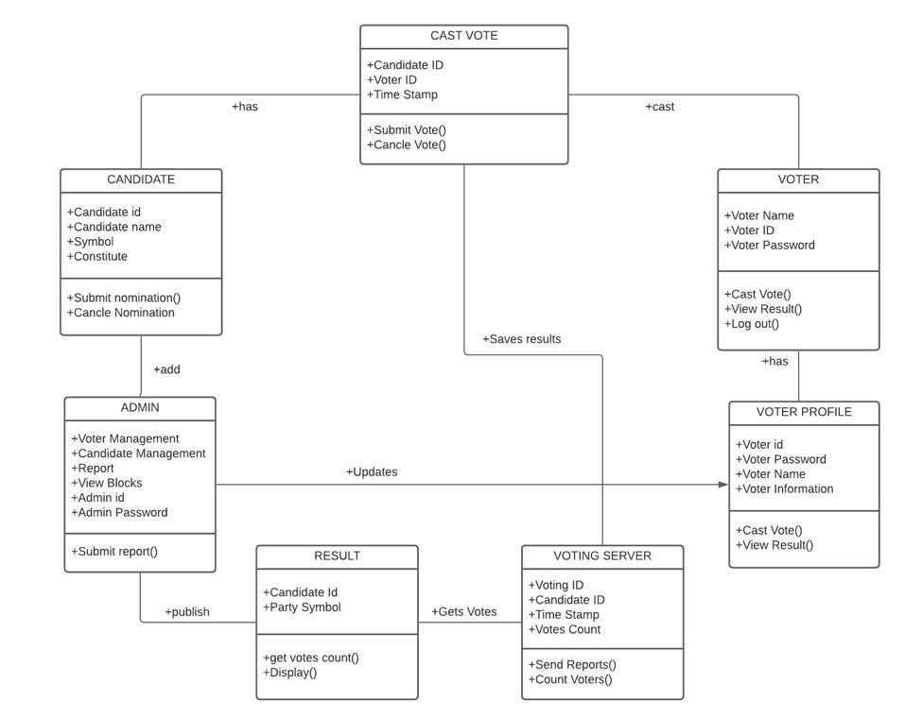

Sequence Diagram:
- Admin
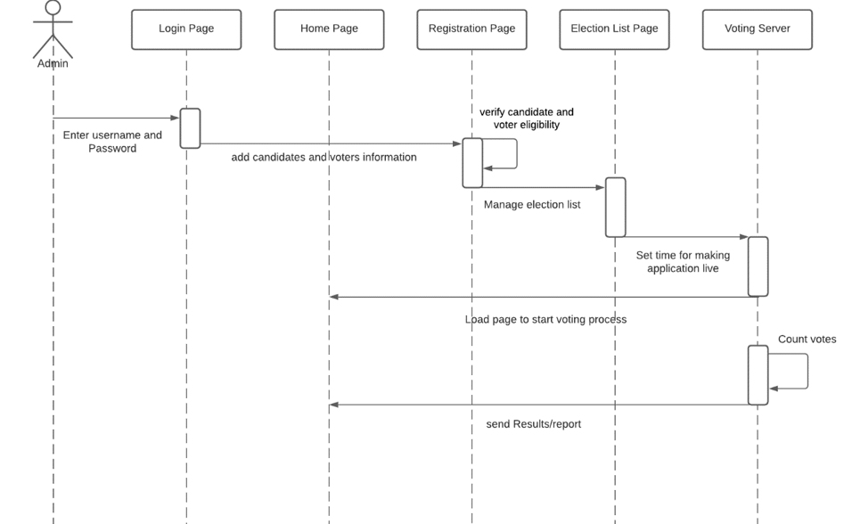

- Candidate
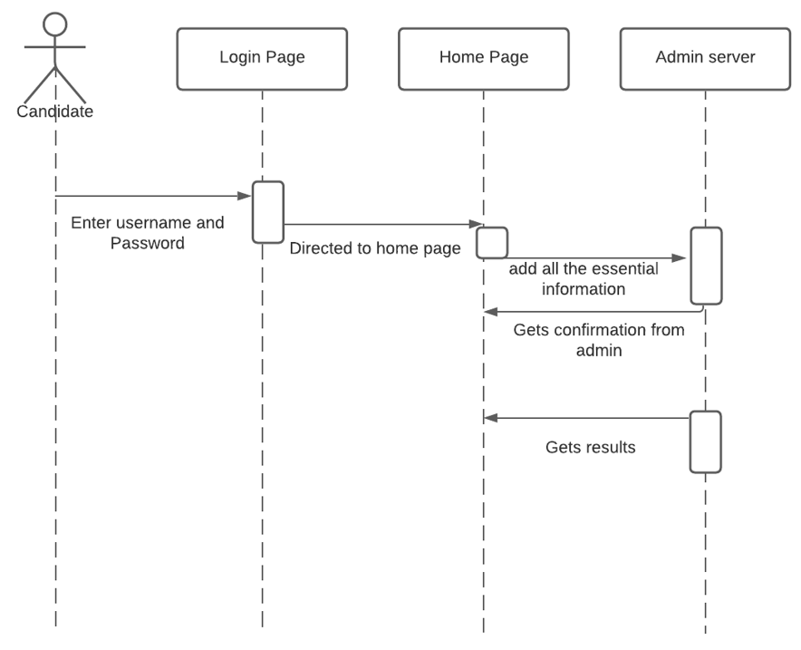
- Voter
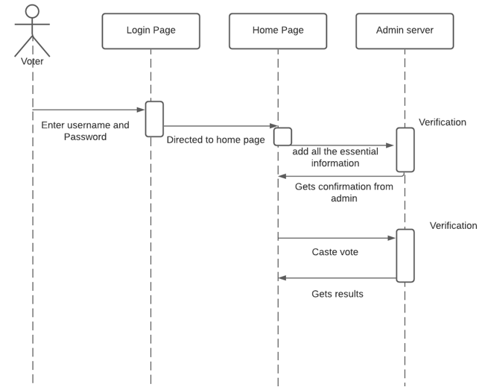

Activity Diagram:
- Voter
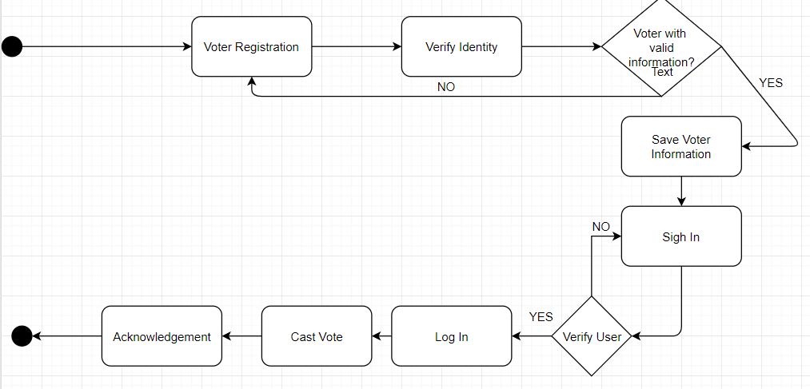
- Candidate
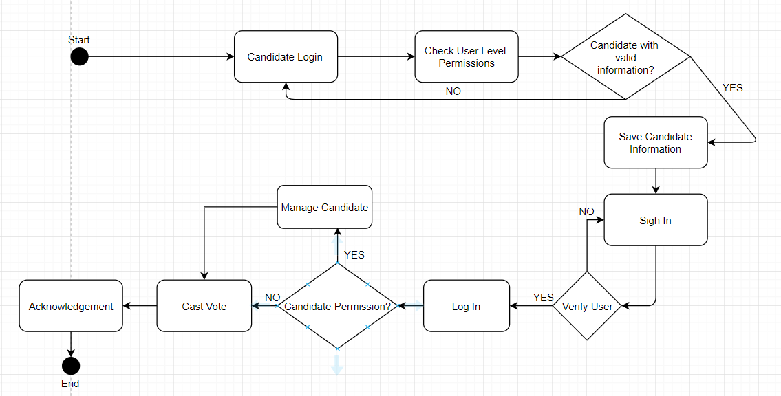
- Admin
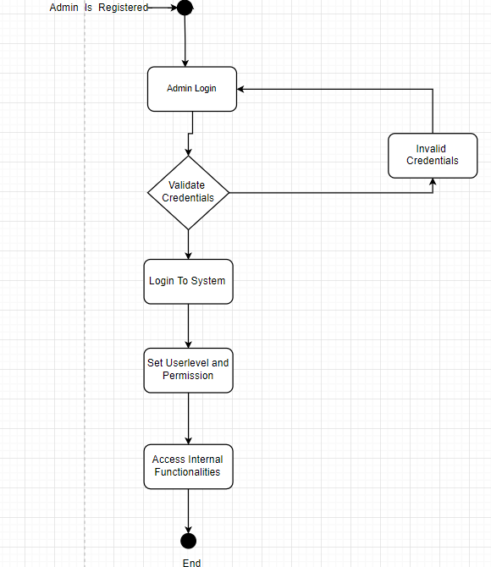

USER STORIES
Here are some user stories (Epics, Features and User Stories)
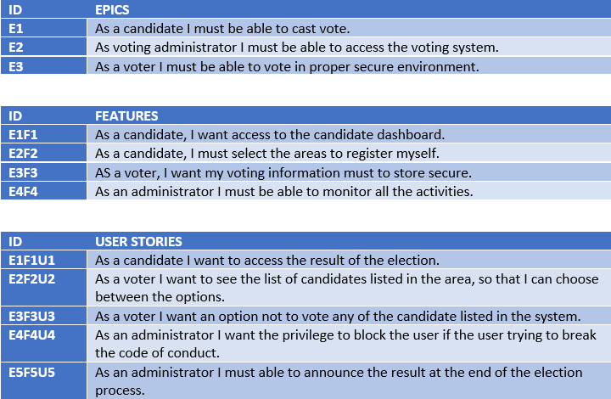

backlog
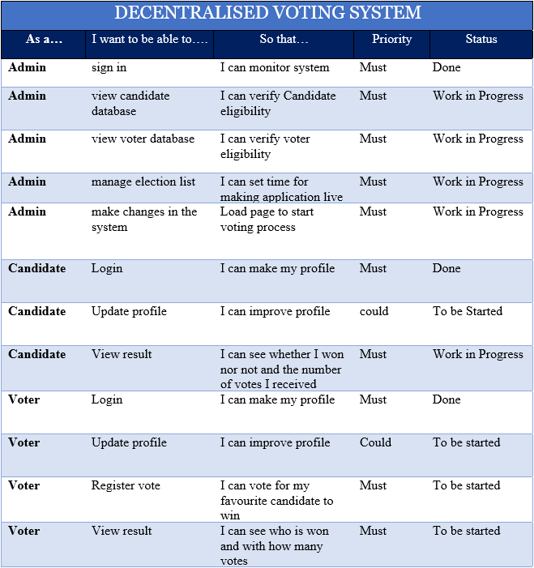

Conclusions and Future Work

Several countries face difficulties in protecting and maintaining the security in the voting systems. To ensure the proper participation of voters, the integrity of the data generated form voting system and the counting of votes without manipulation can be achieved by using a blockchain based voting system which uses smart contract. The transparency of the blockchain enables more understanding of the election process. This mechanism in which the Smart Contracts performs the authentication process of voter or candidates and plays a role in selection of a Miner to compete the transactions in the Blockchain. Counting of the votes will be done immediately which will reduce the time consumption of the election process. Also, this technology provides the environment to voters to cast their vote using smart devices and they can cast their vote from anywhere.

References

- Liu, Y.; Wang, Q. An E-voting Protocol Based on Blockchain. IACR Cryptol. Eprint Arch. 2017, 2017, 1043
- Syada Tasmia Alvi, Mohammed Nasir Uddin and Linta Islam. Digital Voting: A Blockchain-based E-Voting System using Biohash and Smart Contract.
- Uzma Jafar * , Mohd Juzaiddin Ab Aziz and Zarina Shukur. Blockchain for Electronic Voting System—Review and Open Research Challenges.
- Prof. Anita A. Lahane1,∗, Junaid Patel1,∗∗ , Talif Pathan1,∗∗∗ and Prathmesh Potdar1,∗∗∗∗. Blockchain technology based e-voting system.
- Friðrik Þ. Hjálmarsson, Gunnlaugur K. Hreiðarsson School of Computer Science. Blockchain-Based E-Voting System
- Mrs M.Kamala1 , Dharmikesh Kalakonda 2 , Abiram Muppaneni 3 ,Mahesh Pala 4. Decentralised Voting System.
- Andrew Barnes, Christopher Brake and Thomas Perry. Digital Voting with the use of Blockchain Technology.
- Emilbek Joldoshev, Hassan Salahe Matar, Mehmet Barış Özkan and Hüseyin Lutin. Software Requirement Specification For Online National Election Voting.

